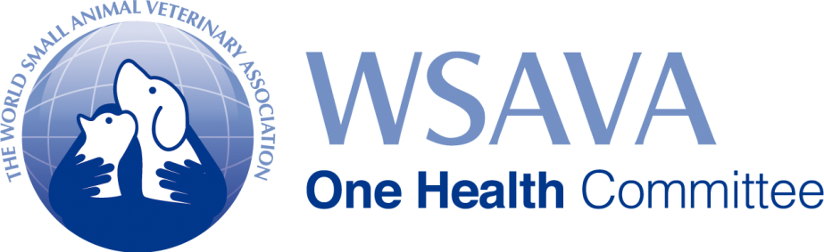

**MANAGING OBESITY IN PEOPLE AND THEIR PETS: A ONE HEALTH SOLUTION**

A recent analysis of global human obesity evaluated data from 19.2 million people in 200 countries over a 40-year period. In 1975 an estimated 3.2% of men and 6.4% of women were obese. By 2014 these statistics had risen to 10.8% of men and 14.9% of women. If these trends continue, it is suggested that by 2025 more women in the human population will be obese than underweight1.

Similar data exist for our canine and feline populations. A 1995 study of 21,754 US dogs revealed that 34% were overweight or obese2 and in the year 2000, 33.5% of 2,661 Australian dogs surveyed were overweight and a further 7.6% of these animals were obese3. In Great Britain, a study published in 2012 reported that 11.5% of 3,227 cats were overweight or obese4. As for people, obesity is linked to a range of disease states in pets, including orthopaedic problems, diabetes mellitus, cardiorespiratory disease, urinary and reproductive disorders, neoplasia and dermatological disease5.

These are worrying trends and the rising rates of obesity in people and their pets is a problem that falls firmly within the area of ‘One Health’. The One Health concept proposes that veterinarians, physicians and other healthcare providers work together with scientists and social scientists to tackle shared human and animal disease problems in the context of the common environment in which we live.

It is recognized that underlying human obesity there are complex medical, psychological and socioeconomic factors and that these factors may impact on the relationships that people with obesity have with their companion animals6. Solutions to the global problem of obesity must lie in a One Health approach and in developing healthier lifestyles for the human and animal members of the family6. Addressing obesity in pets and their owners may be considered a significant public health role for the small animal practitioner7.

In 2010, the World Small Animal Veterinary Association (WSAVA) established a One Health Committee (OHC) and its mission statement is: *To ensure the prominence of the small companion animal-human interface in the global One Health agenda.* The committee works to promote three areas of One Health related to small companion animals: (1) the human–companion animal bond and the health benefits to people of interacting with companion animals, (2) comparative and translational clinical research in companion animals for the benefit of both animal and human health, and (3) the importance of surveillance and control for zoonotic infectious diseases shared between people and companion animals. The committee is made up of a group of veterinary and human medical experts in these fields, with representation from the International Organisation for Animal Health (OIE) and the One Health Office of the US Centers for Disease Control and Prevention (CDC).

The OHC is currently working to present a two-day symposium that will showcase the comparative scientific and interlinked social aspects of human and pet animal obesity, and seek to identify One Health solutions to the problems identified. The symposium, entitled: *Preventing Obesity in People and their Pets: A One Health Approach* will take place in Atlanta, Georgia, between November 9th to 11th this year and is being organized in association with the CDC and other educational partners. The conference will promote the vision of a world where regular activity, a balanced diet and healthy weight are part of every family’s life. Over the two days of this continuing education accredited event, human medical and veterinary experts will address the impact of obesity on clinical diseases such as cardiovascular disease, type II diabetes and cancer; the societal costs, behaviour and psychology of obesity; and practical One Health Solutions to obesity. Further information and registration for the meeting can be found on our designated website: [www.wsava-obesity.com](http://www.wsava-obesity.com). We strongly encourage any veterinarian with an interest in this important subject to register for the meeting.

Michael J. Day

Chairman, WSAVA One Health Committee

**References**

1. NCD Risk Factor Collaboration (2016) Trends in adult body-mass index in 200 countries from 1975 to 2014: a pooled analysis of 1698 population-based measurement studies with 19.2 million participants. *Lancet*, **387**, 1377-1396.

2. Lund EM, Armstrong PJ, Kirk CA, Klausner JS (2006) Prevalence and risk factors for obesity in adult dogs from private US veterinary practices. *International Journal of Applied Research in Veterinary Medicine*, **4**, 177.

3. McGreevy P, Thomson P, Pride C, Fawcett A, Grassi T *et al.* (2005) Prevalence of obesity in dogs examined by Australian veterinary practices and the risk factors involved. *Veterinary Record*, **156**, 695-701.

4. Courcier EA, Mellor DJ, Pendlebury E, Evans C, Yam PS (2012) An investigation into the epidemiology of feline obesity in Great Britain: results of a cross-sectional study of 47 companion animal practices. *Veterinary Record*, **171**, 560.

5. German AJ (2006) The growing problem of obesity in dogs and cats. *Journal of Nutrition*, **136**, S1940-S1946.

6. Sandoe P, Palmer C, Corr S, Astrup A, Bjornvad CR (2014) Canine and feline obesity: a One Health perspective. *Veterinary Record*, **175**, 610-616.

7. Wohl JS, Nusbaum KE (2007) Public health roles for small animal practitioners. *Journal of the American Veterinary Medical Association*, **230**, 494-500.